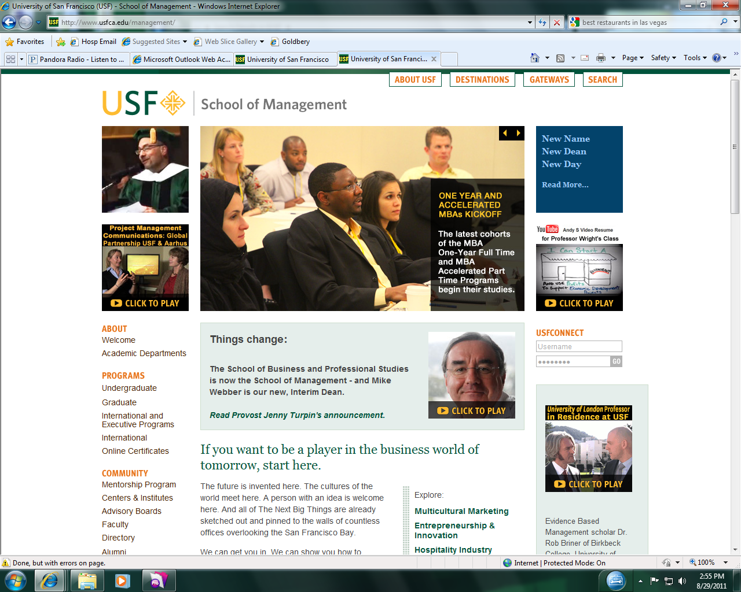

**Department of Hospitality Management**

**JOB/INTERNSHIP POSTING** Please FAX to: (415) 422-6935 or e-mail to: odsatherk@usfca.edu

Company _________________________________

Contact Name

Address__________________________________ _

Phone Fax e-mail

Website

Brief description of your company:

Job title of position being recruited

Brief Job Description/Duties (or attach full description if you have one): .

If this is an internship, the internship will be in the Department and will consist of

Please Describe Minimum Skill/Experience Requirements:

Previous experience

Skills Computer Skills

Languages (indicate language(s) preferred and level of proficiency desired for spoken, written)

Other

Please check all that apply:

Open to: Student 🞏 Graduate 🞏

# 🞏 Job Salary Range: $ _________ 🞏 Union (must join) 🞏 Non-Union

🞏 Internship 🞏 Paid Salary Range: $ _________

# 🞏 Unpaid (If unpaid, Workers Comp insurance waiver/Hold Harmless Agreement must be completed prior to starting)

Hours: F/T🞏 P/T 🞏 If P/T, # Hrs/week Flexible hrs? Yes 🞏 No 🞏

Opportunity available: Immediately 🞏 Future date 🞏 *Beginning when*

Students should: 🞏Contact you direct 🞏 Mail resume w/cover letter 🞏Fax resume

🞏E-mail resume 🞏 Apply in person 🞏Other, please describe:

Please Indicate until what date you would like this to remain posted:

Questions? Please call USF Hospitality Industry Management Program: (415) 422-2581

For information on how to post jobs on-line with USF-Career Services, call (415) 422-6216